
x
Company
Logotype

Cone Beam Computed Tomography- Report



Porur Dental X-rays & CBCT

Patient Name : Mrs. Chitra | Date of Report : 16.07.2024
Age/ Gender : 37 years/ Female | Region of Interest : CBCT Full Skull
Referring doctor: Gayathri Hospital | Indication : Implant assessment
Clinical Notes: Nil
PATIENT INFORMATION

CBCT- Full skull provided
CBCT – IMAGE DETAILS

RADIOGRAPHIC INTERPRETATION

- Completely missing crown and root in relation to 13, 31, 32, 38, 41, 42, 46.
- Root stumps: 36
- Microdont, impacted: 18, 28.
- Presence of bone loss extending beyond the middle third of all teeth that are present.
- Crown in relation to 22, 23

IMPLANT ASSESSMENT

 | 13 region | 22 region
Sub-Crestal | 4.3 | 4
Mid- Crestal | 5.9 | 4.5
Distance between the alveolar ridge and Floor of the Nasal cavity (in mm) | 10.9 | 11.3
Bone type | D3 | D3

 | 31 region | 32 region | 41 region | 42 region
Sub-Crestal (in mm) | 6 | 5.8 | 5.7 | 6.2
Mid- Crestal (in mm) | 6.3 | 6.6 | 6.5 | 7
Distance between alveolar ridge and the inferior border of mandible (in mm) | 20.5 | 21 | 20.3 | 21.5
Bone type | D2 | D2 | D2 | D2

 | 36 region | 46 region
Sub-Crestal (in mm) | 6.4 | 6.5
Mid- Crestal (in mm) | 9.1 | 9.1
Distance between alveolar ridge and the inferior alveolar nerve canal (in mm) | 8.7 | 10.8
Distance between the alveolar ridge and lower border of mandible (in mm) | 18 | 20
Bone type | D2 | D2

RADIOGRAPHIC IMPRESSION

- Partially edentulous maxillary and mandibular arch.
- Root stumps: 36
- Microdont, impacted: 18, 28.
- Generalized chronic periodontitis.

Kindly correlate with clinical findings


IMAGES FOR REFERENCE

RECONSTRUCTED PANORAMIC VIEW
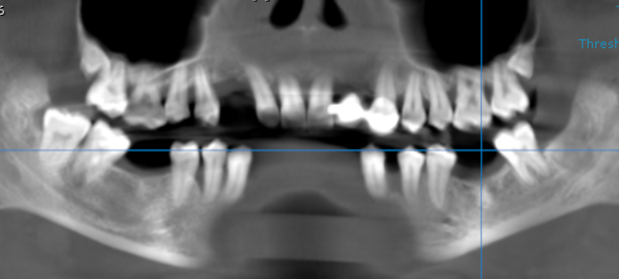

3-DIMENSIONAL VIEW

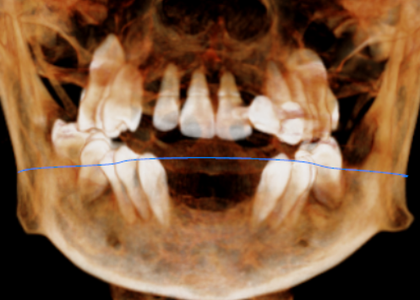

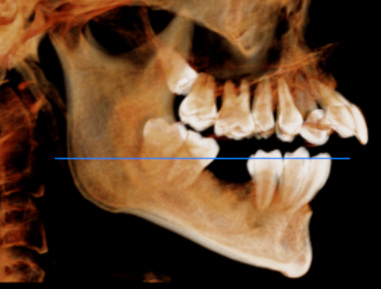
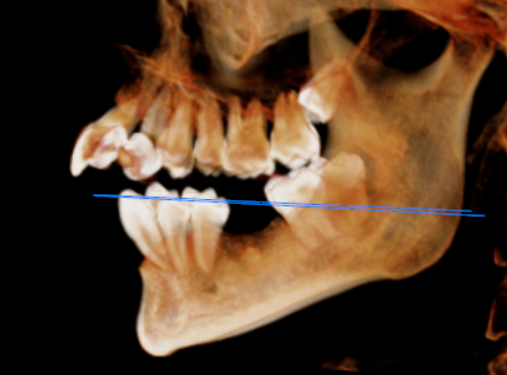

CROSS SECTIONAL VIEW

13 region | 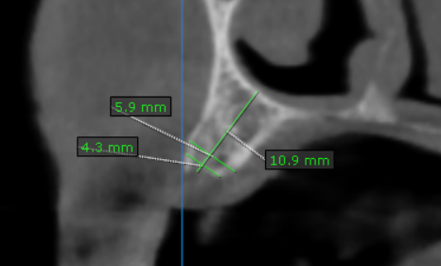
22 region | 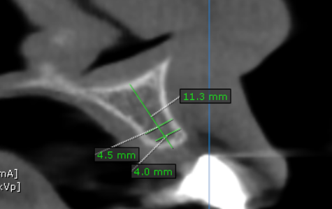
31 region | 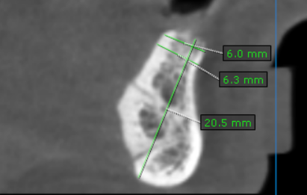
32 region | 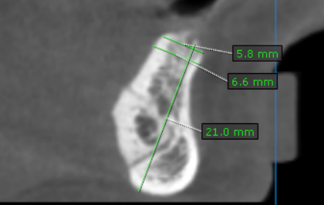
36 region | 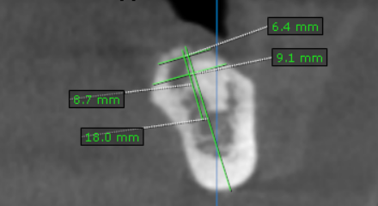
41 region | 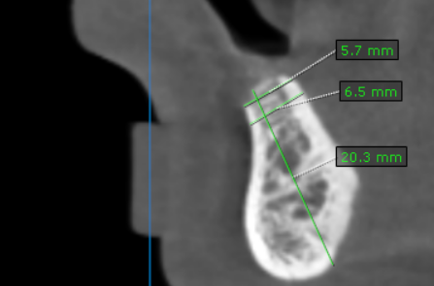
42 region | 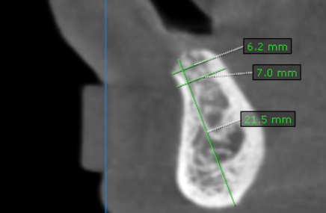
46 region | 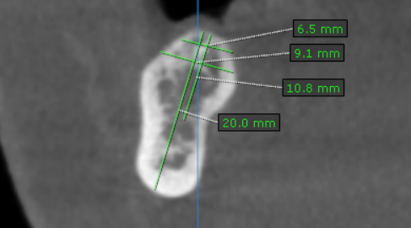

REFERENCE

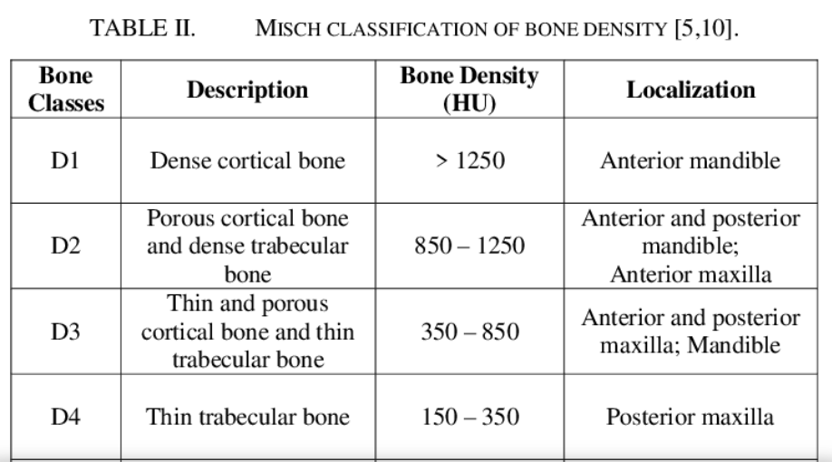

**** End of report ****

